The Effects of Live Television Musicals on Musical Theatre

Colleen Gilgan

Rider University

Dr. N. Haydel

CMP 125

April 27, 2017

**Abstract**

Musical theatre is an important art form that continues to evolve and influence Americans today. Musicals that were once performed on stage for live audiences are now being produced as live television musicals for Americans to watch at home on television. Several live television musicals have been produced, but each musical receives fewer and fewer views and less public interest. Because these live television musicals receive limited positive feedback and lack public interest, a study took place to see if this had any correlation to how Americans felt about musical theatre in general. The study took place through surveys and interviews, both in person and online, with participants of all ages and interests in musical theatre. The researcher discovered that although there are mixed reviews of live television musicals, there is no change to Americans’ opinions of musical theatre. Many Americans believe live television musicals are beneficial to broadening audiences and public interest but need to be improved to be successful.

**Acknowledgements**

The researcher would like to acknowledge and thank all individuals who helped in the making of this report and contributed to its success. The researcher would most like to thank Dr. Nina Haydel for her successful creation of the project and for her prodigious patience and wisdom in and out of class. She is grateful to the interview and survey participants for their valued time and insight into the field and interest of musical theatre. She would like to thank Bethany for her guidance and understanding throughout the study. In addition, the researcher would like to thank A.J. Meeker for his continuous support and advice throughout the study and throughout life. The study would not have been completed without the contribution of these individuals.

**Dedication**

The researcher would like to dedicate this study to her mother, Mary Ellen Gilgan, who has shown the researcher endless love and has always believed in and supported her decision to pursue musical theatre in college and as a career.

**Contents**

List of Figures……………………………………………………………………………………..9

**Section I: Introduction**…………………………………………………………………………10

Introduction……………………………………………………………………………....10

Background of the Study………………………………………………………………...10

Problem Statement……………………………………………………………………….11

Major Question……………………………………..……………………………11

Sub Questions…………………………………………………………………....11

Significance of the Study……………………………………………….………………..11

Overview of Methodology.…………………………………………………………....…12

Limitations and Delimitations………………………………………………………..12-13

Limitations…………………………………………………………………..…...12

Delimitations…………………………………………………………………......13

Definition of Terms……………………………………………………………….….13-15

Summary………………………………………………………………………………..15

**Section II: Literature Review……………………………………………………………….....16**

Introduction…………………………………………………………………………….16

Musical Theatre………………………………………………………………………...16

Components of a Musical…………………………………………………….….17

Production Team…………………………………………………………..……..17

Creative Team…………………………………………………………………....17

NBC TV Network…………………………………………………………………...…...18

Fox Broadcasting Company……………………………………………………………...18

**Section III: Methodology………………………………………………………………....…….20**

Introduction……………………………………………………………………………....20

Major Question…………………………………………………………………………..20

Sub Questions……………………………………………………………………………20

Research Context………………………………………………………………………...20

Research Participants……………………………………………………………...….20-21

Survey…………………………………………………………………………....20

Interviews………………………………………………………………………...21

Instruments to Collect Data……………………………………………………………...21

Sub Questions…………………………………………………………………....21

Procedures………………………………………………………………………………..22

Sub Questions…………………………………………………………………....22

Analysis…………………………………………………………………………………..22

Summary…………………………………………………………………………………23

**Section IV: Results of the Study………………………………………………………………..24**

Introduction……………………………………………………………………………....24

Major Question…………………………………………………………………………..24

Sub Questions…………………………………………………………………………....24

Sub Question 1: How do Americans feel about musical theatre?......................................24

Interview Data………………………………………………………………..24-29

Sub Question 1: How do Americans feel about musical theatre?......................................29

Survey Data…………………………………………………………………..29-35

Sub Question 2: What doaudiences enjoy about live television musicals?......................36

Interview Data………………………………………………………………..36-37

Sub Question 2: What do audiences enjoy about live television musicals?......................37

Survey Data…………………………………………………………………..37-39

Sub Question 3: What do audiences dislike about live television musicals?....................39

Interview Data…………………………………………………………….….39-40

Sub Question 3: What do audiences dislike about live television musicals?....................40

Survey Data………………………………………………………………………42

Summary………………………………………………………………..………………..43

**Section V: Summary and Discussion……………………………………………………..........44**

Statement of the Problem………………………………………………………………...44

Major Question…………………………………………………………………..44

Sub Questions…………………………………………………………………....44

Review of Methodology…………………………………………………………………45

Relationship of Study to Previous Research…………………………………………….45

Summary of Results…………………………………………………………………..46-48

Interpretation and Discussion of Findings…………………………………....46-48

Interpretation…………………………………………………………46-47

Sub Question 1...………………………………………………....46

Sub Question 2….………………………………………………..47

Sub Question 3….………………………………………………..47

Discussion….…………………………………………………………….48

Sub Question 2...………………………………………………....48

Sub Question 3...…………………………………………………48

Summary….……………………………………………………………………………...48

**References…………………………………………………………………………………....49-50**

**Annotated Bibliography…………………………………………………………………….51-52**

**Appendices…………………………………………………………………………………..53-54**

Appendix A….…………………………………………………………………………...53

Appendix B…..…………………………………………………………………………..54

**List of Figures**

Figure 1: Have you ever seen a stage musical?....……………………………………………….30

Figure 2: About how often do you see stage musicals?....……………………………………….31

Figure 3: How have you been involved in musical theatre?.....………………………………….32

Figure 4: How interested are you in musical theatre?....………………………………………....33

Figure 5: Have you ever seen an NBC or Fox live television musical?....………………………34

Figure 6: What was your overall opinion of the live television musicals you have seen?............35

Figure 7: Considering your favorite of the live television musicals you have seen: What did you

enjoy about the musical?.....……………………………………………………………...38

Figure 8: Considering your favorite of the live television musicals you have seen: What did you

dislike about the musical?....……………………………………………………………..41

Figure 9: Have live television musicals changed your opinion of musical theatre in any way?...42

**Section I: Introduction**

Modern western musical theatre has changed dramatically from its early years to modern day, but it has always been a beloved form of entertainment among many Americans. In recent years, traditional stage musicals have been brought to the television screen as live television musical specials by NBC TV Network and Fox Broadcasting Company. These live television musicals have brought in a large number of viewers but have received mostly negative reviews. The researcher conducted the study to find out why there have been negative opinions of the television specials and how this has impacted the reputation of musical theatre. The researcher wanted to find a correlation between the opinions of live television musicals to the reputation of musical theatre in the minds of Americans.

**Background of the Study**

Musical theatre is the incorporation of music, singing, dancing, and spoken dialogue into a theatrical production. These productions, called musicals, were typically performed on a stage for a live audience, but now are being transitioned to reach a wider audience through television. NBC TV Network and Fox Broadcasting Company have been competing for the best live television musical with their previous productions of “The Sound of Music Live!,” “Peter Pan Live!,” “The Wiz Live!,” “Grease Live!,” “The Rocky Horror Picture Show,” and most recently “Hairspray Live!” NBC’s first live television musical, “The Sound of Music Live!,” was released December 5, 2013 (IMDb). The special received almost 22 million viewers, but each production following has failed to achieve even close to that number (O’Connell, 2013). Fiewer views have not discouraged the television networks from producing live television musicals, much to the dismay or appreciation of Americans.

**Problem Statement**

The questions that the researcher answered through research are as follows:

**Major question**

How are live television musicals influencing public opinion of musical theatre in the

minds of Americans?

**Sub-Questions**

1. Why are there mixed reviews of live television musicals?
2. What do audiences enjoy about live television musicals?
3. What do audiences dislike about live television musicals?

**Significance of the Study**

Musical theatre has been a form of entertainment for Americans since the country’s founding. In the last 12 months, 45.92 million people have visited live theatres in the United States (Statista). People from around the country travel to see performances on Broadway in New York City or visit their local community or high school theatre productions to support their community, as well as all levels and shapes of productions in between. The musical theatre industry employs hundreds of thousands of Americans each year (Bureau of Labor Statistics). The industry is important to many Americans and needs to keep improving and being supported by audiences in order to continue.

The new live television productions that are being created bring musical theatre to a wider audience, but fewer people are choosing to watch the productions, creating less of a profit for NBC and Fox networks. Despite a strong national love for the arts, they often are thought as less important than politics, STEM subjects, sports, and other areas and are lacking enough support from Americans. Only about one in four shows on Broadway create a profit, and the television musicals seem to be following this reputation (Seymour, 2016). Despite good intentions to bring musicals to Americans at home, the television musicals are flawed in their attempts to reach and entertain viewers. With aspects such as casting, technological and visual differences, a missing live audience, and many other influences proving a challenge for NBC and Fox, audiences struggle to connect with the productions and then begin to disconnect from musical theatre (Evans, 2015). Without this connection between productions and their viewers, musical theatre will not be able to continue.

**Overview of Methodology**

The researcher studied the effects of live television musicals among viewers by using the instruments of surveys and interviews. The researcher surveyed college students and adults in the professional world on their opinions of live television musicals. The surveys were handed out physically to some participants and conducted online for others. The researcher also interviewed musical theatre professionals on their opinions of the productions and asked whether or not they believe the productions are improving the progress and reputation of musical theatre. Two professionals were of the XYZ University musical theatre faculty, a voice teacher and an accompanist, and the third professional was a musical theatre music director.

**Limitations and Delimitations**

**Limitations**

The limitations the researcher faced throughout her research was a lack of communication and available time to meet with her interview participants and an extreme difference in the ratio of survey participants who had seen a stage musical before or were interested in musicals to those who had not seen a stage musical or were not interested in musicals. The researcher had difficulty contacting the interview participants and finding time where they were available to be interviewed. The researcher also had many more participants who were interested or involved in musical theatre than not, so the survey data is biased.

**Delimitations**

All participants surveyed, interviewed, and observed were of a variety of ages but all over the age of 15. Participants involved had varying experience with musical theatre, from professional or community experience to no experience with theatre. Two professionals in musical theatre from the XYZ University faculty were interviewed.

**Definition of Terms**

* Accompanist: A person who provides musical accompaniment on piano to a singer
* Audience: Assembled spectators of a public or live event, such as a stage musical or a television musical
* Broadway: Theatrical performances presented in the professional theatres in Midtown Manhattan, New York City, which are considered at the highest level of commercial theatre in America
* Celebrity: A famous or well-known person in society, often known for singing or acting in films or television
* Choreographer: A person who composes the sequence of steps and moves to music for the performance of a musical
* Criticism: The negative judgment of the faults or mistakes of a television musical
* Director: A person who oversees and orchestrates the operation of a musical theatre production by unifying the different components of the production
* Fox Broadcasting Company: An American commercial broadcast television network that is owned by Fox Entertainment Group, or 21st Century Fox which produces news, sports, entertainment specials, and other specials
* Live: An event happening in real-time, as events happen, in the present
* Musical director: The person responsible for the musical aspects of a musical theatre production
* Musical theatre: A form of theatrical performance that combines singing, spoken dialogue, acting, and dance
* NBC TV Network: Stands for the National Broadcasting Company; American commercial broadcast television network that is owned by NBCUniversal and Comcast which produces news, sports, entertainment, and other television specials
* Performer: A person involved in a musical theatre production who entertains an audience
* Production team: The group of technical staff who produce a musical, including a director, musical director, choreographer, and other individuals
* Progress: The improvement of quality, portrayed talent, creativity, and reception of a musical theatre production
* Reputation: The beliefs or opinions that are generally held about musical theatre
* Review: Evaluation of a musical production
* Stage musical: A musical theatre production performed live on a stage for a physically present audience
* Television musical: A musical theatre production performed on television, sometimes live, to an audience watching from their homes
* Television special: A segment of content intended for broadcast on cable or internet television
* Viewer: A person who watches a television special
* Western musical theatre: Musical theatre performed in the United States intended for American audiences

**Summary**

NBC TV Network and Fox Broadcasting Company continue to create live television musicals in order to bring musical theatre to a wider audience and to break boundaries of television. The researcher used the data found in this research project to prove that television musicals are not improving the reputation or progress of musical theatre. Through surveys, interviews, and observation, the researcher determined whether Americans think that live television musicals are a benefit to musical theatre. This demonstrates that television musicals do not work to surpass their own expectations and the expectations of Americans.

**Section II: Literature Review**

Musical theatre has evolved immensely from its beginning to what it is today. Musicals began on the stage but have slowly been transferring on to the screen, just as films have been moving to stage productions. With advancements in technology, standards are being raised for musicals by production teams and audiences alike. Musicals are now being produced on live television with celebrity casts and continue to gain a large amount of viewers. NBC TV Network and Fox Broadcasting Company have both produced several live television musicals, receiving both praise and criticism from audiences. Live television musicals and their mixed reviews can have both a positive and negative impact on musical theatre as a whole.

**Musical Theatre**

Musical theatre is a type of theatre that combines music, singing, spoken dialogue, and dance to tell a story and evoke an emotional response (New World Encyclopedia). Musical theatre pieces, known as musicals, are performed throughout the world in many different forms. The scale of musicals range from large, well-known productions, such as on Broadway in New York City or the West End in London, to amateur community or high school productions, which are generally smaller in scale, budget, and cast size. In a musical, a character begins to sing because spoken dialogue is not enough to express the deep emotion he or she feels or to reinforce an idea or situation to the audience or other characters. There are several different types of musicals, including book musicals, revues, concept musicals, jukebox musicals, and rock or pop musicals (James, 2012). Different styles of musical theatre have evolved throughout many years and have lead to the way it is today.

**Components of a Musical**

There are three main components of a musical production - the music, the lyrics, and the book. The book of a musical refers to its story, characters, spoken dialogue, and structure. The book and lyrics are sometimes referred to together, as a “libretto.” The music and lyrics together make up the “score” of a musical (James, 2012). There are normally at least six songs in a musical, broken up by spoken dialogue in between, but some musicals consist of all music with no spoken dialogue. Songs in a musical libretto are strategically placed at emotional highpoints of the musical where dialogue is no longer enough to express the emotion being felt (Kenrick, 2003).

**Production Team**

Many individuals contribute to the production of a musical, including the producer, stage manager, casting director, actors, and many others. Producers make all of the arrangements for the production of a show, handle marketing the show to audiences, and find investments to pay for the production’s run (Baggaley, 2008). The stage manager schedules all rehearsals, manages all props, set pieces, and costumes, and notes all technical and staging “cues” for all of the actors and technical crew to follow (Musicals 101, 2003). The casting director chooses what actors will be in the show and who will be portraying which characters. The actors make up the cast of a show and are the ones to perform the musical on stage. Each individual in the making of a musical is important to the final production.

**Creative Team**

There are also many individuals who contribute to the creation of a musical, including the composer, lyricist, librettist, director, choreographer, technical designers, and musical director, as well as many others. The composer writes the music of a musical, while the lyricist writes the lyrics of the songs. The librettist creates the book of a musical and makes sure the spoken dialogue and music work together to tell the story. The director must interpret the script and guide the actors in performing the show (AACT). The choreographer creates dance to the songs of the musical and teaches it to the actors to perform. The technical designers create the lighting, sound, set, costumes, props, and many other aspects of a musical. The musical director guides the actors in their singing of the songs and sometimes also conducts the orchestra (Musicals101, 2003). There are many more individuals who contribute to a musical, and they are all imperative to its creation.

**NBC TV Network**

The National Broadcasting Company (NBC) is an American television broadcasting network under the ownership of NBCUniversal. The company began as a radio broadcasting, and with the advancement of technology, smoothly transitioned to television. Once television was produced in color, NBC became very popular with a long list of television specials (Our History). Today, the network is still very popular and produces some of the most watched television shows. The channel also consists of a news special and a sports special. In recent years, NBC started producing live television musicals. The very first live television musical was “The Sound of Music,” starring Carrie Underwood as Maria (IMDb, 2013).

**Fox Broadcasting Company**

The Fox Broadcasting Company (FOX) is an American television broadcasting company and a subsidiary of 21st Century Fox (Encyclopedia Britannica, 2017). From its beginning in 1986, the company continued extending its broadcasts until it was on seven nights a week. The broadcasting company has increased in popularity in recent years and is the host of many popular television shows. It is also popularly known for its Fox News Channel with several different specials on the channel. After NBC began gaining viewers from its live television musicals, Fox produced its own live television musical, “Grease Live!,” on January 31, 2016 (IMDb, 2016).

**Section III: Methodology**

Within the past few years, musicals have been transitioned to live productions on television. The researcher conducted the study to find out if the musicals are changing the opinions of musical theatre in the minds of Americans. The researcher conducted the extensive research to answer the major and sub-questions about the reputation of live television musicals. Interviews and surveys were created and conducted to find the data.

**Major question**

How are live television musicals influencing public opinion of musical theatre in the

minds of Americans?

**Sub-Questions**

1. Why are there mixed reviews of live television musicals?
2. What do audiences enjoy about live television musicals?
3. What do audiences dislike about live television musicals?

**Research Context**

The study took place at XYZ University in New Jersey, a private university with a diverse student body and faculty. The research was conducted at the end of March into the beginning of April, over the course of two weeks. The survey was kept open online for two weeks, and the interviews were conducted within this two week period.

**Research Participants**

**Survey**

The participants of the survey were both male and female and of many different ages, which ranged from 16 to 70. Several of the participants were college students, of all different majors. A portion of the College students were Fine and Performing Arts majors. Some of the participants had never seen a musical or had never been involved in a musical theatre production, while other participants were employees in the theatre industry or performers in community theatre.

**Interviews**

The interview participants were all adults between the ages of 30 and 60and were all employed in the theatre industry. One participant was a regular musical director for community theatre productions. The second participant used to act and now mainly directs community theatre productions. The third participant was a high school choir director and a musical and technical director for high school productions.

**Instruments to Collect Data**

**Sub-Questions**

1. Why are there mixed reviews of live television musicals?

In order to answer the first sub-question, the researcher conducted separate interviews with three participants. Interview questions were asked to understand the participants’ opinions of what the purpose of live television musicals is and if it the musicals are successful in achieving this purpose (See Appendix A).

1. What do audiences enjoy about live television musicals?
2. What do audiences dislike about live television musicals?

Sub-questions two and three were answered through the use of interviews and surveys. Three participants were interviewed to understand their opinions of live television musicals and what specifically they enjoyed or disliked about the live television musicals. Surveys were also conducted with anonymous participants to gain an understanding of what the general population enjoys and dislikes about live television musicals (See Appendix B).

**Procedures**

**Sub-Questions**

1. Why are there mixed reviews of live television musicals?

The researcher created interview questions to ask the participants what they thought was the purpose of live television musicals and if it was successful. The researcher chose the participants based on their theatre credentials and contacted them to set up a time to conduct the interview. The researcher met with Participant A in person at a diner and conducted the interview over a meal. The interviews with Participants B and C were conducted over the phone.

1. What do audiences enjoy about live television musicals?
2. What do audiences dislike about live television musicals?

The researcher conducted interview questions to ask the participants specifically what they enjoyed and disliked about live television musicals and why they felt that way about the particular aspect. The researcher then created a survey that asked participants to choose what they enjoyed or disliked from a list of options. The survey also asked participants what they would change about live television musicals. The survey was conducted online over the course of two weeks. Physical copies of the survey were also handed out in different college classrooms where participants marked their answers on the paper.

**Analysis**

The interview participants’ answers were quoted but lightly edited for clarity and length. Irrelevant information was deleted. The data from the survey questions are shown as graphs and explained in detail in narratives. The questions are separated into categories of enjoyment and dislike and change of opinion.

**Summary**

The researcher conducted the study on a college campus, with most of the instruments taking place online. The researcher went through specific methodology to create the instruments and distribute them to her participants. The participants of the surveys and interviews were chosen specifically on their interest or disinterest in musical theatre. Specific questions from the interviews and surveys answered the sub-questions. The interviews and surveys will be displayed in categories to answer the sub-questions.

**Section IV: Results of the Study**

Modern musical theatre in America has recently transitioned to live productions on television. The live television musicals have received mixed reviews but continue to be produced. The researcher conducted her study to see if the mixed reviews of the live television musicals were influencing the Americans’ pre-existing opinions of musical theatre. The researcher used interviews and surveys to find her data. The interview and survey participants were both those involved and uninvolved in musical theatre. The data is shown in quoted interviews and charts.

**Major question**

How are live television musicals regressing public opinion of musical theatre in the

minds of Americans?

**Sub Questions**

1. How do Americans feel about musical theatre?
2. What do audiences enjoy about live television musicals?
3. What do audiences dislike about live television musicals?

**Sub Question 1: How do Americans feel about musical theatre?**

**Interview Data**

Interview Question 1: What is your personal experience with musical theatre?

Participant A: “I have been performing in musical theatre since I was eight years old. I was in my first show as a member of the Boys Band in Music Man back in 1990. My father was a musical director, so I pretty much didn’t have a choice as to what kind of hobby I was going to have. He was doing it, and I found it as a way to connect with him. I have been performing in musicals, performing in plays, musically directing shows, conducting orchestras, stage managed, directed, produced, done stage crew. I...even have a choreography credit to my name. I have done everything except build a set, and that’s probably a good thing.”

Participant B: “I grew up surrounded by musical theater. My father was a

total jock, but had every cast album he could find. I remember terrorizing my

family when the Jesus Christ Superstar double album was released by running through the house twirling rolls of unrolling toilet paper singing “Hosanna!” I have acted in and directed musical theater now for over 35 years.”

Participant C: “I have been involved in musical theater as either a performer or director since 1985. I have been the musical director/coach for at least 50 productions. I have also worked as a technical director, sound designer, and lighting designer on over 75 productions.”

**Sub Question 1: How do Americans feel about musical theatre?**

**Interview Data**

Interview Question 2: What do you think about musical theatre is beneficial to society?

Participant A: “I think it provides people a way to throw themselves into a different time period or a different landscape. I think it tells a very interesting story. Musicals help tell the story, and you leave the theatre with a song in your heart and tapping your feet. I feel that musicals help people forget about what kind of world we live in for awhile.”

Participant B: “I believe the idea of taking a personal thought or experience and letting it sing from your soul and heart is an action that everyone can relate to.”

Participant C: “At its best, musical theater can draw attention to social issues that are sometimes difficult to discuss in public. It can create a dialogue between people that didn't exist before. It can be a conduit to self-realization, to our history and to where we are going in the future.”

**Sub Question 1: How do Americans feel about musical theatre?**

**Interview Data**

Interview Question 3: What do you think would attract more people to theatre?

Participant A: “I think there needs to be more relatable topics. There needs to be more shows about more common world problems, as opposed to first world problems. With theatre as a whole, I think there needs to be more variety. We can’t keep recycling the same shows every fifteen years. People wanted to see “Hamilton,” because it was topical and a different genre of music that was attached to a show and it was interesting. It appealed to another group of the common man. I think the formula of theatre needs to be altered a little. It feels like plot lines are very predictable. Also, the prices of tickets need to go way down. When I was a kid, I saw “Phantom of the Opera” for maybe an eighth of what tickets for “Hamilton” are going for right now. For me, I am a musical purist, so I love the old work horses, and I would love to see more shows that have real dancing and real talent. I want to see something that is akin to what I used to see as a kid. I think that would not only attract the older crowd that has maybe given up on theatre because it is the same thing every year but attract the younger audience enthused about doing musicals again.”

Participant B: “I am encouraged by the growing participation of young students in theater within their educational environments. The growing number of talented community theater troupes is also encouraging. Unfortunately, the cost of producing the large Broadway productions demands extremely high ticket pricing. I hope other Broadway productions can learn from “Hamilton” by introducing ticket scholarships and performances opened for student audiences.”

Participant C: “I think that the re-invigoration of the movie industry's interest in musicals has helped. Productions like Chicago, Hairspray, Rent, Les Mis and Into the Woods are on the right track to showing the public what theater is really like. Maybe it will cause them to check out a national tour or a local community theater.”

**Sub Question 1: How do Americans feel about musical theatre?**

**Interview Data**

Interview Question 4: Have you seen any of NBC’s or Fox’s live television musicals? If so, which musicals have you seen?

Participant A: “I saw ‘Peter Pan Live!,’ ‘Sound of Music Live!,’ and ‘Hairspray Live!’”

Participant B: “I grew up watching the annual airings of “Peter Pan” and “Cinderella” in the 1960’s. Oddly, I have not been drawn to watch the latest incarnations of the television musicals. And honestly, in our home we have discontinued cable. With our limited down time, we are completely satisfied with Roku, Netflix and Amazon for television watching. Social media makes it so easy to watch small snippets within minutes of the actual airing. If I like what I see, I can then go and hunt and find a full viewing.”

Participant C: “I have seen The Sound of Music, Peter Pan and Grease Live.”

**Sub Question 1: How do Americans feel about musical theatre?**

**Interview Data**

Interview Question 5: What is your opinion of the live television musicals you have seen - individually and overall?

Participant A: “I have hated them. I’ve hated everything I have seen. I thought ‘Sound of Music Live!’ was terrible. I think that the hype about ‘The Sound of Music Live!’ was not about the TV musical. The hype was about Carrie Underwood. The hype wasn’t about ‘Peter Pan Live!’ The hype was about Allison Williams and Christopher Walken. The television musical with Mary Martin as Peter Pan was so well done. Yes, you could see wires, and yes, you could tell it was a live theatre production, but there was something so simple about it. Now, people are getting too creative instead of letting the art speak for itself. What bothered me about ‘Hairspray Live!’ was the commercial breaks showing the actors setting up for the next scene. I don’t want to see that. That ruins the experience for me. I feel like every television musical has taken a step back. When I see a show, I want to be entertained and I want to forget that I am watching something. I don’t want to see boom mics or shadows or things that are coming up in the next scene.”

Participant B: “Because live theater is such a part of my life, I seem to be unable to get beyond the belief that everything is “live.” Camera angles have been pre-thought, sets are built on a much larger scale than any theater, and the acting missing something from a live audience. I believe there must be something different for an actor to be followed by a camera in lieu of hundreds of live eyes.”

Participant C: “Overall I am a supporter of them. I was impressed with Carrie Underwood's courage to try such a role in The Sound of Music. (Although I didn't feel like it was a good match for her vocally and her acting was a bit of a disappointment.) Without her, that first musical-for-tv wouldn't have been made. It needed the star-power of her name to get the first on off of the ground. So, for that I am grateful to her. I would much rather see live-televised productions of shows currently in production in the houses they are performed in. Similar to the recent SHREK release and some other productions you are able to locate on

DVD.”

**Sub Question 1: How do Americans feel about musical theatre?**

**Survey Data**

Survey Question 1: Have you ever seen a stage musical?

**Figure 1**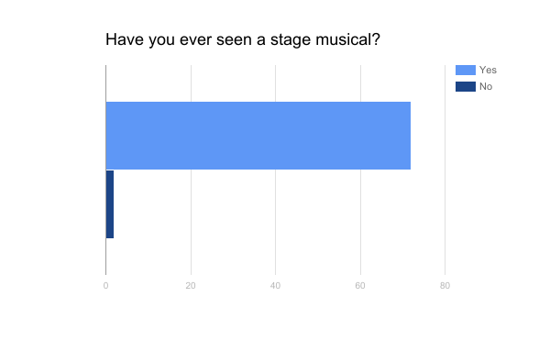

Figure 1 shows the number of people surveyed who have seen a stage musical before. The top bar of the chart, in a light blue color, represents the number of participants who have seen a stage musical. The bar on the bottom of the chart, in a dark blue color, represents the number of participants who have not seen a stage musical. Out of all of the survey participants, 72 participants had seen a stage musical before, and 2 participants had not.

**Sub Question 1: How do Americans feel about musical theatre?**

**Survey Data**

Survey Question 2: About how often do you see stage musicals?

**Figure 2**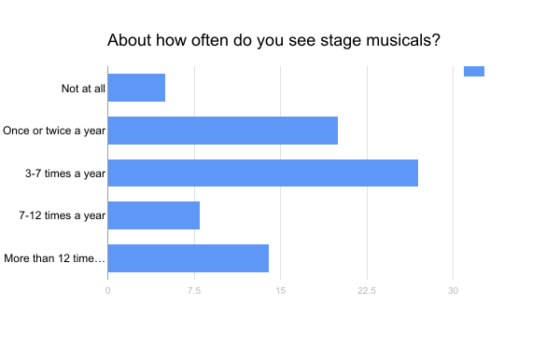

Figure 2 represents how often the survey participants see stage musicals in an average year of their life. The top bar represents the number of participants who do not see stage musicals at all. The second bar from the top represents the number of participants who see stage musicals once or twice a year. The middle bar represents the number of participants who see stage musicals 3-7 times a year. The second to last bar represents the number of participants who see stage musicals 7-12 times a year. The last bar represents the number of participants who see stage musicals more than 12 times a year. Five participants do not see stage musicals at all in an average year. Twenty participants answered that they see stage musicals once or twice a year. Twenty-seven participants see stage musicals 3-7 times a year. Eight participants see stage musicals 7-12 times a year. Fourteen participants see stage musicals more than 12 times a year.

**Sub Question 1: How do Americans feel about musical theatre?**

**Survey Data**

Survey Question 3: How have you been involved in musical theatre?

**Figure 3**

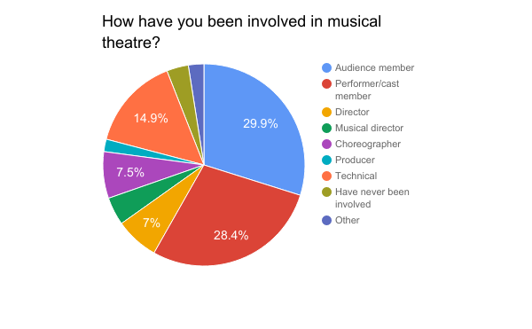

Figure 3 is a pie chart representing the percentages of the participants who have been involved in different aspects of musical theatre. Each color represents a different aspect - audience member, performer/cast member, director, musical director, choreographer, producer, technical, have never been involved, and other. Sixty of the participants, or 29.9%, have been an audience member for a musical theatre production. Fifty-seven participants, or 28.4%, have been a performer or a cast member. Fourteen participants, or 7%, have been a director of a musical. Nine participants have been a musical director. Fifteen, or 7.5%, people have been a choreographer for a musical theatre production. Four participants have acted as a producer, while 30 participants have worked on the technical side of a musical. Seven participants have never been involved in a musical, and five participants have worked in other aspects of musical theatre that are not listed.

**Sub Question 1: How do Americans feel about musical theatre?**

**Survey Data**

Survey Question 4: How interested are you in musical theatre?

**Figure 4**

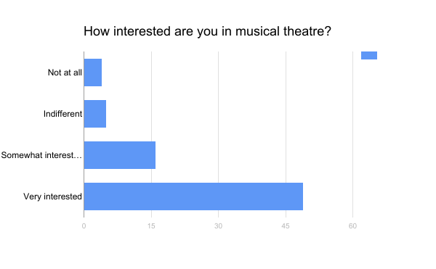

Figure 4 shows the different levels of interest in musical theatre among the survey participants. The top bar shows the number of participants who are not interested in musical theatre at all. The second bar shows the number of participants who are indifferent towards musical theatre. The second to last bar shows the number of participants who are somewhat interested in musical theatre. The last bar shows the number of participants who are very interested in musical theatre. Of the responses, four participants were not interested at all, five participants were indifferent, 16 participants were somewhat interested, and 49 participants were very interested.

**Sub Question 1: How do Americans feel about musical theatre?**

**Survey Data**

Survey Question 5: Have you ever seen a Fox or NBC live television musical (Sound of Music, Peter Pan, The Wiz, Grease, Hairspray)?

**Figure 5**

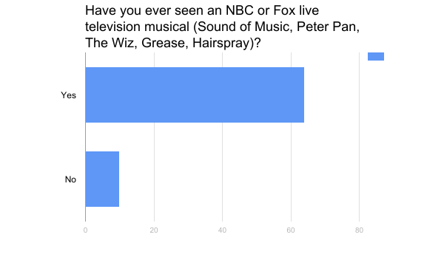

Figure 5 represents the number of participants who have seen a live television musical. The top bar represents the number of participants who have seen a live television musical, while the bottom bar represents the number of participants who have not. Out of the responses, 64 participants had seen a live television musical and 10 participants had not.

**Sub Question 1: How do Americans feel about musical theatre?**

**Survey Data**

Survey Question 6: What was your overall opinion of the live television musicals you have seen?

**Figure 6**

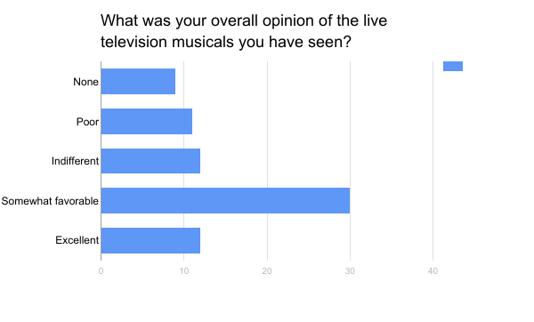

Figure 6 represents the different opinions the survey participants had of live television musicals. Each bar represents a different level of opinion - none, poor, indifferent, somewhat favorable, and excellent. Nine survey participants had never seen a live television musical and could not form an opinion. Eleven participants had a poor opinion of the live television musicals they had seen. Twelve participants were indifferent to the musicals. Thirty participants had a somewhat favorable opinion of the live television musicals. Twelve participants felt the live television musicals they had seen were excellent.

**Sub Question 2: What do audiences enjoy about live television musicals?**

**Interview Data**

Interview Question 6: What is beneficial about live television musicals to musical theatre and society in general?

Participant A: “I think that there are people in this world that feel that maybe they can’t afford to see theatre or that theatre doesn’t really apply to them or that theatre is not something they would see themselves seeing or doing. I think bringing television musicals to the masses is important in the development of theatre in society. I think there is a lot more work that needs to be done with it, but I think it is good for theatre because it does give people opportunities. There have been stereotypes and a stigma about the arts. Showing that on television gives people the opportunities to think differently about the arts and to raise future generations with a different opinion about the arts.”

Participant B: “If this is the way to introduce and perpetuate classic pieces to the next generation, then how can I fault it?”

Participant C: “They will hopefully expand their marketability in the public and broaden awareness of the artform. The danger is if they forget the focus of the theater in general and stop trying to move people and think about only entertaining them.”

**Sub Question 2: What do audiences enjoy about live television musicals?**

**Interview Data**

Interview Question 7: How can television musicals attract more people?

Participant A: “They need to stop hiring celebrities who cannot sing to be lead roles in these musicals. I think the talent level needs to be better. I think the production quality needs to be tighter. I think they need to get rid of the commercial breaks and seeing the production from an inside perspective. It is a musical. It is not reality TV. It is art. Treat it that way.”

Participant B: “Might they attempt to work with pieces that are not so dated? Maybe introduce more modern pieces such as “Fun Home,” “Falsettos” or “Dear Evan Hanson.” And film them within their theater settings!”

Participant C: “The best way to attract more people is by producing high quality productions. Productions that say something. I fear that the "fluff factor" may be too much for one of the directors to avoid and then we will lose that outlet after a huge ratings flop.”

**Sub Question 2: What do audiences enjoy about live television musicals?**

**Survey Data**

Survey Question 7: Considering your favorite of the live television musicals you have seen: What did you enjoy about the musical?

**Figure 7**

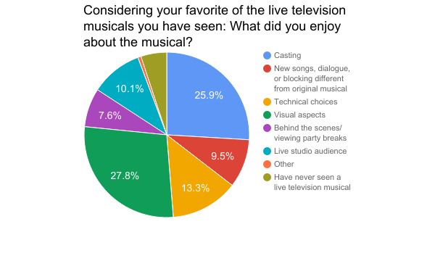

Figure 7 represents the different aspects of live television musicals that the survey participants enjoyed. Each color represents a different theatrical aspect - casting, new songs, dialogue, or blocking different from original musical, the technical choices made, the visual aspects, behind the scenes or viewing party breaks, or the live studio audience. Participants could also answer if they had never seen a live television musical or enjoyed something other than what was listed. In regards to the casting of the live television musicals, 41 participants, or 25.9%, enjoyed the casting. When the production team added new songs, dialogue, or blocking that was different than the original musical, 15 participants enjoyed the new additions. Twenty-one participants enjoyed the technical choices the production team made, and forty-four participants enjoyed the visual aspects on screen. Twelve participants enjoyed the behind the scenes or viewing party breaks in between scenes. Sixteen participants enjoyed the live studio audience on set. Eight participants had never seen a live television musical, and therefore could not describe what they enjoyed. One participant listed they they enjoyed something else that was not listed in the question.

**Sub Question 3: What do audiences dislike about live television musicals?**

**Interview Data**

Interview Question 8: How are television musicals changing the reputation of musical theatre?

Participant A: “I think they are portraying musical theatre in a negative way, but I don’t think they are doing it in a way that it will affect musical theatre for years to come. There will still be television musicals. They are going to keep happening. I had such high hopes for ‘The Sound of Music Live!,’ but when a show is not rehearsed enough and you can see a cameraman or obvious mistakes, it ruins the show. You cannot blame mistakes on the fact that it is live. Stage musicals rehearse months for a production and do not make the mistakes that live television musicals portray. Mistakes should not be shrugged off because that takes away credit from theatre performers who do not make any mistakes, even though it is still live.”

Participant B: “I don’t know that they are.”

Participant C: “I am not sure that they really have at this point. We will know in another 5-10 years how much of an impact these few productions have had. If we see a sharp rise in young singer/actors over this time, there may be a correlation to be made between the two.”

**Sub Question 3: What do audiences dislike about live television musicals?**

**Interview Data**

Interview Question 9: Is there anything else you would like to say about musical theatre or live television musicals?

Participant A: “I am not giving up on television musicals. If it is something I want to see, I will see it, but I want the next show to be cast correctly and to be super tight in its rehearsal.”

Participant B: “I remain optimistic.”

Participant C: “I have been blessed to work in this genre for a very long time. I am always excited to see a production, especially a new show. The amount of creativity in the world is amazing, I love to see what creative people can do and that adds to my excitement. Musical Theatre has the ability to move us in ways we can't imagine. I crave that every day. I am always looking for something to really MOVE me. If I had one regret as a professional, it would be that I wasn't introduced to it as a performer from my childhood.”

**Sub Question 3: What do audiences dislike about live television musicals?**

**Survey Data**

Survey Question 8: Considering your favorite of the live television musicals you have seen: What did you dislike about the musical?

**Figure 8**

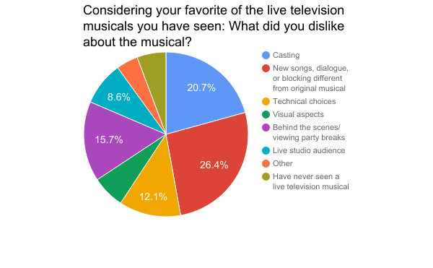

Figure 8 represents the different aspects of live television musicals that the survey participants disliked. Each color represents a different aspect of the musicals - casting, new songs, dialogue, or blocking different from the original musical, the technical choices made, the visual aspects, the behind the scenes or viewing party breaks, or the live studio audience. Participants could also list if they had not seen a live television musical or if they disliked something about the musicals that was not listed. Twenty-nine participants, or 20.7%, did not like the casting of the live television musicals. New songs, dialogues, or blocking did not please 37, or 26.4% of, participants. Seventeen participants disliked the technical choices, and nine participants disliked the visual aspects. Twenty-two participants disliked the use of behind the scenes and viewing party commercial breaks. Twelve participants did not like the live studio audience that was present during the productions. Eight participants had never seen a live television musical and could not give an opinion on what they disliked. Six participants disliked other things in the live television musicals that were not listed in the question.

**Sub Question 3: What do audiences dislike about live television musicals?**

**Survey Data**

Survey Question 10: Have live television musicals changed your opinion of musical theatre in any way?

**Figure 9**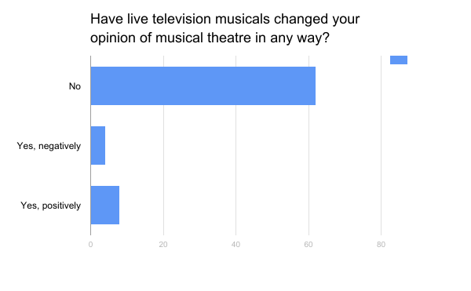

Figure 9 shows the results of whether live television musicals have changed the participants’ opinions of musical theatre. The first bar represents the amount of participants whose opinion has not changed. The second and third bar represents the amount of participants whose opinion of musical theatre has changed, either positively or negatively. Of the participants’ responses, 62 participants’ opinions were not changed, four participants’ opinions were changed negatively, and eight participants’ opinions were changed positively.

**Summary**

The researcher conducted interviews and surveys which were quoted or presented as figures. The interview questions and responses found out specific details on what audiences enjoy or dislike about live television musicals. The survey questions determined the differences in opinions. The interviews were more general, while the surveys had specific choices to pick from. The researcher will use this data to determine if opinions of live television musicals alter the opinions of musical theatre.

**Section V: Summary and Discussion**

Modern western musical theatre has changed dramatically from its early years to modern day, but it has always been a beloved form of entertainment among many Americans. In recent years, traditional stage musicals have been brought to the television screen as live television musical specials by NBC TV Network and Fox Broadcasting Company. These live television musicals have brought in a large number of viewers but have received mostly negative reviews. The researcher conducted the study to find out why there have been negative opinions of the television specials and how this has impacted the reputation of musical theatre.

**Statement of the Problem**

Musical theatre has been a form of entertainment for Americans since the country’s founding. 45.92 million people visited live theatres in the last 12 months in the United States (Statista). People from around the country travel to see performances on Broadway in New York City or visit their local community or high school theatre productions to support their community, as well as all levels and shapes of productions in between. The musical theatre industry employs hundreds of thousands of Americans each year (Bureau of Labor Statistics). The industry is important to many Americans and needs to keep improving and being supported by audiences in order to continue.

**Major question**

How are live television musicals regressing public opinion of musical theatre in the

minds of Americans?

**Sub-Questions**

1. How do Americans feel about musical theatre?
2. What do audiences enjoy about live television musicals?
3. What do audiences dislike about live television musicals?

**Review of Methodology**

The study took place at XYZ University, a private university in New Jersey. The surveys and interviews were conducted at the end of March into the beginning of April over the course of two weeks. A portion of the participants were college students, and the rest were adults - both involved in musical theatre and not. The researcher created interview questions to ask the participants what they thought was the purpose of live television musicals and if it was successful. The researcher chose the participants based on their theatre credentials and contacted them to set up a time to conduct the interview. The researcher conducted interview questions to ask the participants specifically what they enjoyed and disliked about live television musicals and why they enjoyed or disliked the particular aspect. The researcher then created a survey that let participants choose what they enjoyed or disliked from a list of options. The survey also asked participants what they would change about live television musicals.

**Relationship of Study to Previous Research**

The new live television productions that are being created bring musical theatre to a wider audience, but less people are choosing to watch the productions, creating less of a profit for NBC and Fox networks. Despite the national love they receive, the arts often are thought as less important than politics, STEM subjects, sports, and other areas and are lacking enough support from Americans. Only about one in four shows on Broadway turn a profit, and the television musicals seem to be following this reputation (Seymour, 2016). Despite good intentions to bring musicals to Americans at home, the television musicals are flawed in their attempts to reach and entertain viewers. With aspects such as casting, technological and visual differences, a missing live audience, and more proving a challenge for NBC and Fox, audiences struggle to connect with the productions and then begin to disconnect from musical theatre (Evans, 2015). Without this connection between productions and their viewers, musical theatre will not be able to continue.

**Summary of Results**

**Interpretation and Discussion of Findings**

**Interpretation**

**Sub Question 1: How do Americans feel about musical theatre?**

Musical theatre tells a story to its audience through not only words but music and movement. Musicals evoke many different kinds of emotion that remain with a person long after the performance has ended. Audiences can experience a different time period or a different point of view while remaining in their seats at the theater. Musicals allow people to forget about the problems in their own lives and find new experiences. Musicals offer a way for people to connect with others. They are a source of entertainment and community, for audience members and for those involved in the productions. Cast members, crew members, and production staff members connect with each other through a like interest to create a unique piece of art that will leave a lasting effect on others. Community theatre and school level productions offer a safe place to have fun and be oneself with like-minded individuals. Professional productions offer employment to those involved and benefits to those in the union.

Live television musicals share all of the purposes of musical theatre but spread these benefits to a wider audience. People can still be entertained, experience new things, release emotion, and connect with others from a live television musical. Different from a stage musical, however, individuals who do not want to or cannot see a stage musical due to financial, geographical, or social reasons can now see a musical within the privacy of their own home for free. People do not need to spend money on a ticket or transportation and do not need to be embarrassed or ashamed for watching a musical. Many people associate stereotypes or stigma with musicals and other art forms, but when musicals are shown on television, musical theatre can be accepted more or at least become a private event. People who would not normally see a stage musical may watch a live television musical, even just out of curiosity, and find a new interest or connection with another person or be able to relate to the topics or issues represented in the musical.

**Sub Question 2: What do audiences enjoy about live television musicals?**

Most individuals who have seen the live television musicals enjoy the visual aspects or the casting of the productions the most. They like the way the creators of live television musicals create the set, costumes, lighting, etc. and use the camera angles and television work to their advantage.

**Sub Question 3: What do audiences dislike about live television musicals?**

Most audiences to live television musicals do not like the new additions to the musicals. New songs, dialogue, or blocking have been added to the live television productions in order to benefit the celebrities they cast in lead roles. Audiences do not appreciate the use of new works that do not flow with the original work in the show and do not fit the nostalgia and original feeling the show holds.

**Discussion**

**Sub Question 2: What do audiences enjoy about live television musicals?**

**Sub Question 3: What do audiences dislike about live television musicals?**

The data was not what the researcher expected. The researcher understood what the participants enjoyed and disliked, but she expected these opinions to affect the overall opinions of Americans. Despite not enjoying the live television musicals as a whole, the overall opinions of musical theatre did not change and remained generally positive.

The researcher recommends further research be done to determine whether or not there is a difference in the opinions of live television musicals between those who are interested in musical theatre and those who are not. As live television musicals continue to be produced, the data may need to be updated.

**Summary**

The research from the study showed that live television musicals are not seen in a positive light but do not change the reputation of musical theatre. Both those interested and uninterested in musical theatre had a generally similar experience. The data went against the researcher’s original hypothesis but showed a positive difference.

**References**

*Actors* [Fact sheet]. Retrieved from U.S. Bureau of Labor Statistics database.

Baggaley, L. (2008, April 4). What’s the producer’s role? *The Guardian.* Retrieved from

https://www.theguardian.com/stage/theatreblog/2008/apr/04/whatstheproducersrole

Bianco, R. (2016, December 8). Our critic ranks TV's live musicals, from 'Peter Pan' to

'Hairspray'. *USA Today*. Retrieved from [https://www.usatoday.com/story/life/tv/](https://www.usatoday.com/story/life/tv/columnist/2016/12/08/our-critic-ranks-tvs-live-musicals-peter-pan-hairspra)

[columnist/2016/12/08/our-critic-ranks-tvs-live-musicals-peter-pan-hairspra](https://www.usatoday.com/story/life/tv/columnist/2016/12/08/our-critic-ranks-tvs-live-musicals-peter-pan-hairspra)

y/95140092/

Director. *American Association of Community Theatre.* Retrieved from

https://www.aact.org/director

Driscoll, M. (2016, December 7). NBC musicals return with 'Hairspray': Why do we still want

live shows? *The Christian Science Monitor*. Retrieved from [http://www.csmonitor.com/](http://www.csmonitor.com/The-Culture/TV/2016/1207/NBC-musicals-return)

[The-Culture/TV/2016/1207/NBC-musicals-return](http://www.csmonitor.com/The-Culture/TV/2016/1207/NBC-musicals-return)-with-Hairspray-Why-do-we-still-want-

live-shows

Elber, L. (2016, December 6). Hairspray live! Telecast pushes boundaries. *Toronto Star*.

Retrieved from Points of View Reference Center database. (Accession No.

6FPTS2016120640800078)

Evans, S. You're only live once: Big musicals hit the small screen, with no retakes. *American*

*Theatre*. Retrieved from <http://www.americantheatre.org/2015/12/01/>youre-only

-live-once-big-musicals-hit-the-small-screen-with-no-retakes/

*Facts on theatre & Broadway* [Fact sheet]. Retrieved from Statista database.

Fox Broadcasting Company. (2017, February 9). *Encyclopedia Britannica.* Retrieved from

https://www.britannica.com/topic/Fox-Broadcasting-Company

Genzlinger, N. (2016, December 8). After 'Hairspray Live!': 7 TV musicals and 5 lessons

learned. *NY Times*. Retrieved from <https://www.nytimes.com/2016/12/08/arts/television/>

seven-tv-musicals-five-lessons-learned.html?_r=0

Grease Live! (2016, January 31). *Internet Movie Database.* Retrieved from

http://www.imdb.com/title/tt4366830/

James, J. (2012, February 22). Musical theatre powerpoint. *Slideshare.* Retrieved from:

https://www.slideshare.net/JeremyJames/musical-theatre-powerpoint

Musical theater. (2014, December 16). *New World Encyclopedia*. Retrieved from

[http://www.newworldencyclopedia.org/p/index.php?title=Musical_](http://www.newworldencyclopedia.org/p/index.php?title=Musical_Theater&oldid=985719)

[Theater&oldid=985719](http://www.newworldencyclopedia.org/p/index.php?title=Musical_Theater&oldid=985719).

O'Connell, M. TV ratings: NBC's 'Sound of Music Live' nears 22 million viewers with DVR. *The*

*Hollywood Reporter*. Retrieved from [http://www.hollywoodreporter.com/live-](http://www.hollywoodreporter.com/live-feed/tv-ratings-nbcs-sound-music-66754)

[feed/tv-ratings-nbcs-sound-music-66754](http://www.hollywoodreporter.com/live-feed/tv-ratings-nbcs-sound-music-66754)

Our history. Retrieved March 9, 2017, from NBCUniversal.com website:

http://www.nbcuniversal.com/our-history

Seymour, L. (2016, December 8). Why do NBC's live musicals keep tanking? *Forbes*. Retrieved

from <https://www.forbes.com/sites/leeseymour/2016/>12/08/

why-do-nbcs-live-musicals-keep-tanking/#452c41bf32ef

The Sound of Music Live! [Fact sheet]. Retrieved from *Internet Movie Database*.

<http://www.imdb.com/title/tt3141866/>

**Annotated Bibliography**

Bianco, R. (2016, December 8). Our critic ranks TV’s live musicals, from ‘Peter Pan’ to

‘Hairspray.’ *USA Today.* Retrieved from [https://www.usatoday.com/story/life/tv/](https://www.usatoday.com/story/life/tv/columnist/2016/)

[columnist/2016/](https://www.usatoday.com/story/life/tv/columnist/2016/)12/08/our-critic-ranks-tvs-live-musicals-peter-pan-hairspray/95140092/

NBC's *Hairspray Live!* was the least-watched yet of the five musicals aired on the major networks in recent years. But it was tops in USA TODAY TV critic Robert Bianco's book. A ranking, including excerpts from reviews.

Genzlinger, N. (2016, December 8) After ‘Hairspray Live!’: 7 TV musicals and 5 lessons

learned. *The New York Times.* Retrieved from <https://www.nytimes.com/2016/12/08/>

arts/television/seven-tv-musicals-five-lessons-learned.html

“The Wiz” was the best by far. But in terms of [ratings](http://www.nytimes.com/2016/02/02/arts/television/grease-live-scores-big-ratings.html?_r=0), which is what this is really

all about, “The Sound of Music” is the king (more than 18 million viewers), fueled no doubt by a curiosity factor, since it was first. “Grease” is second at about 12 million, then and “The Wiz” at 11.5 million. Preliminary numbers for “Hairspray” put it somewhat behind those. But in general the bloom seems to be off the rose, and these musicals are settling into a good-but-not-spectacular ratings zone.

Seymour, L. (2016, December 8) Why do NBC’s live musicals keep tanking? *Forbes.* Retrieved

from <https://www.forbes.com/sites/leeseymour/2016/12/08/>

why-do-nbcs-live-musicals-keep-tanking/#3b640e3532ef

*Hairspray Live!* was the [least successful yet](http://www.forbes.com/sites/hughmcintyre/2016/12/08/hairspray-hits-a-new-ratings-low-for-nbcs-live-musicals/#119f0c807df3) in NBC's string of live musicals. It

garnered just 9.04 million viewers, placing it below the network's three previous offerings, and [far below](http://variety.com/2016/tv/news/hairspray-live-ratings-dec-7-1201937092/) the guarantees made to ad buyers.

Shellard, D. (2010, November 11) Showtime: A history of the Broadway musical theatre. *Times*

*Higher Education.* Retrieved from <https://www.timeshighereducation.com/books/>

showtime-a-history-of-the-broadway-musical-theater/414139.article

Larry Stempel's beguiling history of Broadway musical theatre, *Showtime*, has at

its heart a very simple premise: that up until the premiere of *Oklahoma!*, musicals were, in effect, musical comedies, and after that date they became musical plays and true examples of musical theatre. Stempel's canvas is enormous, but his touch is deft and precise, and for those requiring some colour, glamour and melody to hum in this new age of austerity - a phrase our politicians are not using now with quite the same relish as they did last summer - then this is the book for you.

Tommasini, A. (2011, July 7). Opera? Musical? Please respect the difference. *The New York*

*Times.* Retrieved from <http://www.nytimes.com/2011/07/10/theater/>

Musical-or-opera-the-fine-line-that-divides-them.html

Drawing from different genres and styles can, of course, produce dynamic results. In contemporary classical music, some of the most interesting young composers are those who unabashedly steal from the diverse musical styles that excite them — atonal modernism, punk, whatever — to fashion a quirky and personal voice. But opera and especially musical theater are art forms with specific needs and challenges. Traditions, even those supposedly confining categories, have their value.

**Appendices**

**Appendix A**

**Interview**

1. What is your personal experience with musical theatre?
2. What about musical theatre do you think is beneficial to society?
3. What do you think would attract more people to theatre?
4. Have you seen any of NBC’s or Fox’s live television musicals? If so, which musicals have you seen?
5. What is your opinion of the live television musicals you have seen - individually and overall?
6. What is beneficial about live television musicals to musical theatre and society in general?
7. How can live television musicals attract more people?
8. How are live television musicals changing the reputation of musical theatre?
9. Is there anything else you would like to say about musical theatre or live television musicals?

**Appendix B**

**Survey**

Please mark each answer clearly.

#### Have you ever seen a stage musical (community, high school, regional, Broadway, etc.)?

* Yes
* No

1. About how often do you see stage musicals?

* Not at all
* Once or twice a year
* 3-7 times a year
* 7-12 times a year
* More than 12 times a year

3. How can you been involved in musical theatre? (Choose all that apply)

* Audience member
* Performer/cast member
* Director
* Musical director
* Choreographer
* Producer
* Technical
* Have never been involved
* Other (please specify):

4. How interested are you in musical theatre?

* Not at all
* Indifferent
* Somewhat interested
* Very interested

5. Have you ever seen an NBC or Fox live television musical? (Sound of Music, Peter Pan, The Wiz, Grease, Hairspray)?

* Yes
* No

6. What was your overall opinion of the live television musicals you have seen?

* None
* Poor
* Indifferent
* Somewhat favorable
* Excellent

7. Considering your favorite of the live television musicals you have seen: What did you enjoy about the musical? (Choose all that apply)

* Casting
* New songs, dialogue, or blocking different from original musical
* Technical choices
* Visual aspects
* Behind the scenes/viewing party breaks
* Live studio audience
* Other (please specify):

8. Considering your favorite of the live television musicals you have seen: What did you dislike about the musical? (Choose all that apply)

* Casting
* New songs, dialogue, or blocking different from original musical
* Technical choices
* Visual aspects
* Behind the scenes/ viewing party breaks
* Live studio audience
* Other (please specify):

9. What would you change for future live television musicals? (If you have not seen live television musicals, describe what you think the live television musicals should include.)

10. Have live television musicals changed your opinion of musical theatre in any way?

* No
* Yes, negatively
* Yes, positively